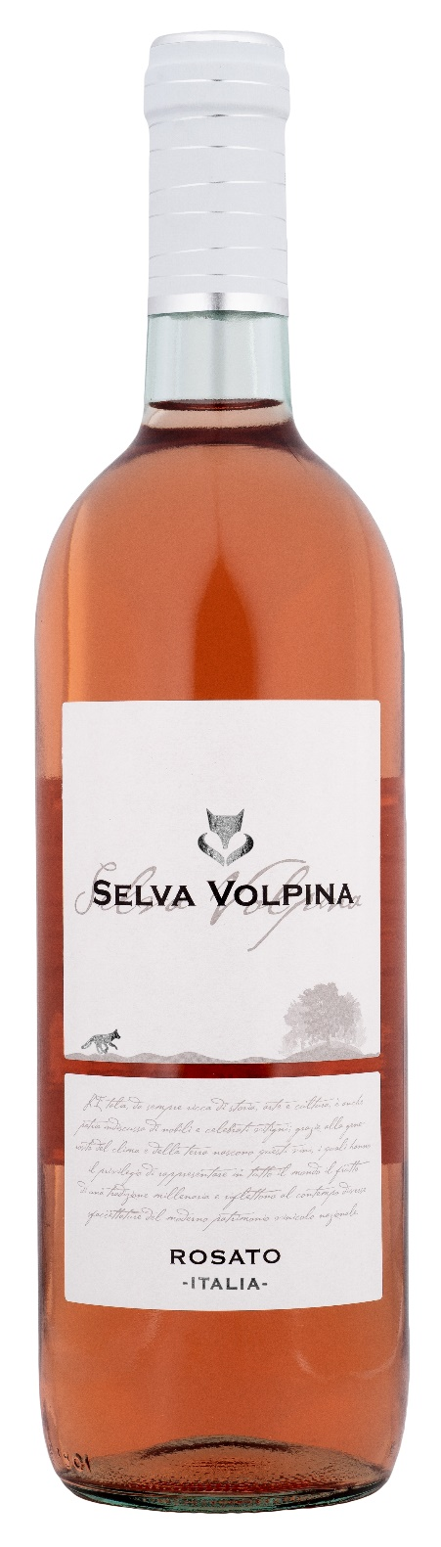
ROSATO TERRE D’ABRUZZO – SELVA VOLPINA

Grape: Merlot 100%
Alc. Vol.%: 12
Vintage: 2025
Residual sugar g/l: 4,1
Total acidity g/l: 5,8
Production zone: Vineyards in Central Italy
Capacity: 750ml

CHARACTERISTICS

Vinification: Light pressing and short contact with the skins. Fermentation at a controlled temperature
Aging: In steel tanks until bottling
Yield per ha: 16000kg
Colour: Bright, lively rosé
Bouquet: Fresh and fruity
Flavour: Well-balanced, pleasant and harmonious

SERVING SUGGESTIONS

Best enjoyed as an aperitif, with starters, soups, white meat and grilled fish.
Serving temperature 8-10 °C
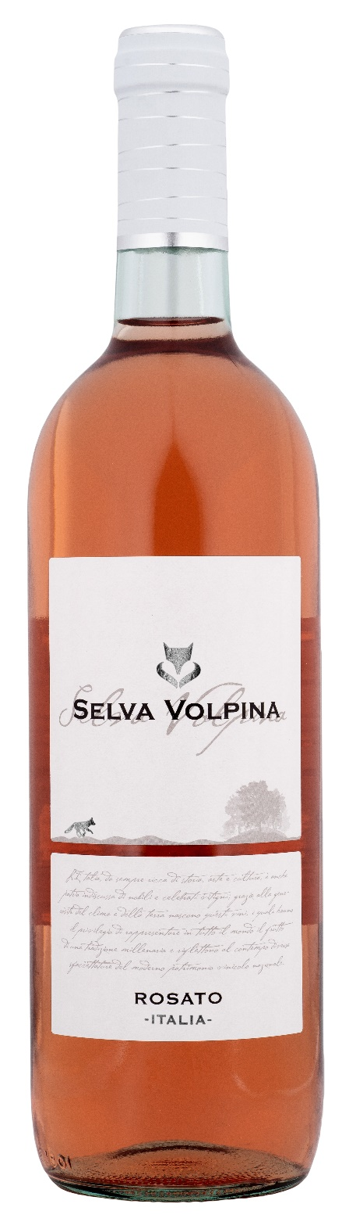
TECHNICAL INFORMATION / PALLETIZING

Size 750ml:
Article Nr. V10011A
GTIN-13 bottle 8017868004868
GTIN-13 carton 8017868004875
Closure Cork/Screwcap
Bottles / carton 6 bottles
Pallet size 80x120cm
Cartons/layer 25
Cartons/pallet 125
Kg/carton 7,2
Kg/pallet 925

Contains sulphites
GMO Free
Revisione 01. 14.05.2026

